Name : Shreyash Shete
Batch : May 2022

SQL Assignment

Library System

Use the following Schema to perform the given set of assignment.

Tables-

Member – It contains information about the members
Column Name | Data Type | Description
Member_Id | Number(5) | Unique Member ID
Member_Name | Varchar2(30) | Name of the Library member
Member_address | Varchar2(50) | Address of the member
Acc_Open_Date | Date | Date of membership
Membership_type | Varchar2(20) | Type of the membership such as ‘Lifetime’,’ Annual’,  ‘Half Yearly’,’ Quarterly’
Fees_paid | Number(4) | Membership fees paid
Max_Books_Allowed | Number(2) | Total Number of books that can be issued to the member.
Penalty_Amount | Number(7,2) | Penalty amount due

Books- It contains information about the books belongs to the library
Column Name | Data Type | Description
Book_No | Number(6) | Book identification number
Book_Name | VarChar2(30) | Name of the book
Author_name | Varchar2(30) | Author of the book
Cost | Number(7,2) | Cost of the book
Category | Char(10) | Category like Science , Fiction etc.

Issue – It contains the information about issue of the books
Column Name | Data Type | Description
Lib_Issue_Id | Number(10) | Library Book Issue No
Book_No | Number(6) | Number of the book issued
Member_Id | Number(5) | Member that issued the book
Issue_Date | Date | Date of Issue
Return_date | Date | Return date

Day # 3 Assignments (Estimated Time: 3 Hrs)

Concept: Group by, Having, Use of Aggregate functions.
Set Operators
Joins
Sub query: Inline, Co-related, complex queries.

Objective: At the end of the assignments, participants will be confident to understand the various concepts related to extracting data from multiple tables, relationship, Set operators and complex queries.

Task / Problems:

- List the various categories and count of books in each category.

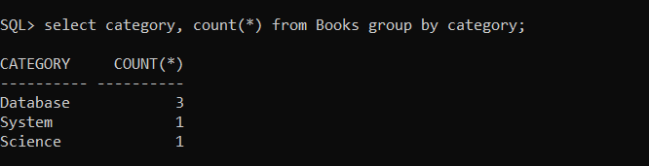

- List the book_No and the number of times the book is issued in the descending order of count.

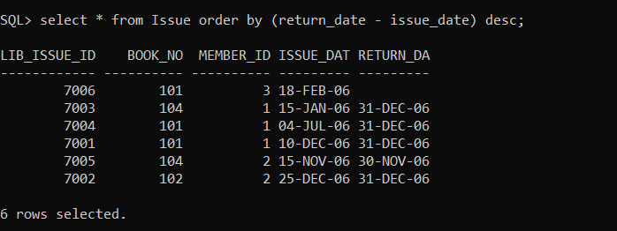

- Find the maximum, minimum, total and average penalty amount in the member table.

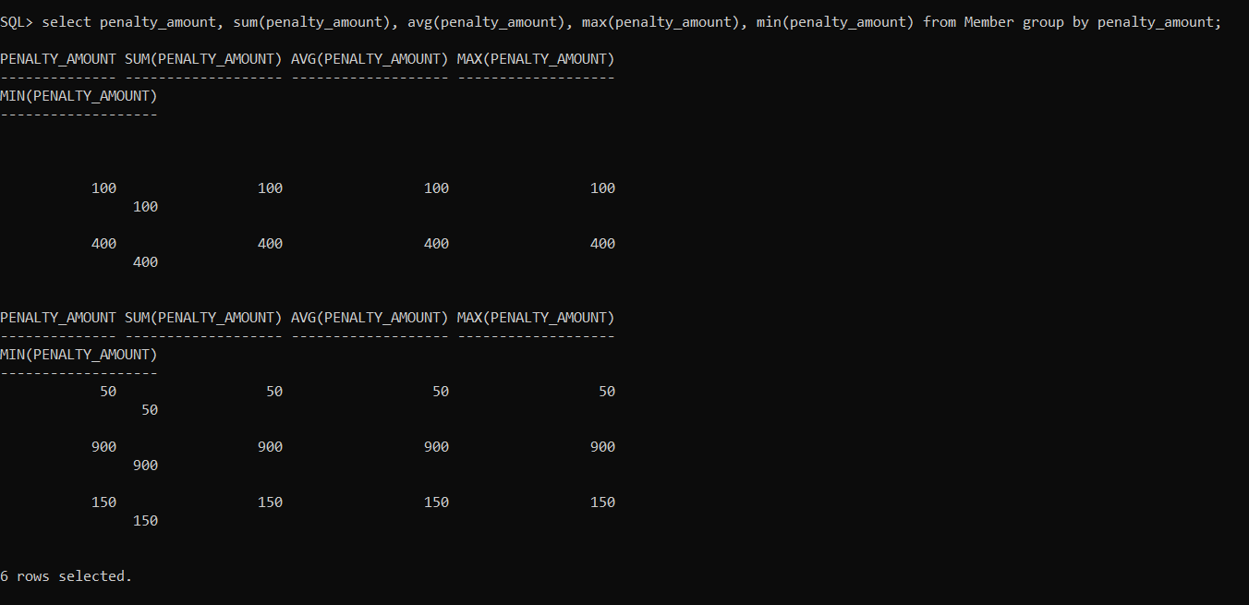

- Display the member id and the no of books for each member that has issued more then 2 books.

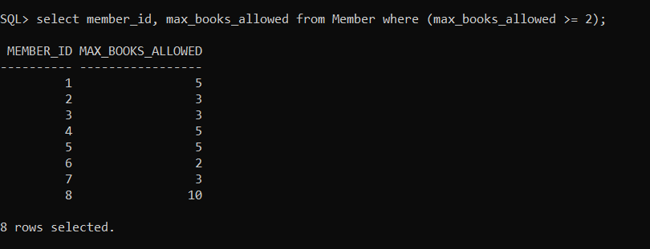

- Display the member id, book no and no of times the same book is issued by the member in the descending order of count.

- Display the month and no of books issued each month in the descending order of count.

- List the book_no of all the books that are not issued to any
member so far.

- List all the member id that exist in member table and has also at least one book issued by them.

- List the member ID with highest and lowest no of books issued.

- List all the Issue_details for books issued in December and July without using any arithmetic, Logical or comparison operator.

- List the Book_No, Book_Name and Issue_date for all the books that are issued in month of December and belong to category Database.

- List the Member Id, Member Name and No of books Issued in the descending order of the count.

- List the Book No, Book Name, Issue_date and Return_Date for all the books issued by Richa Sharma.

- List the details of all the members that have issued books in Database category.

- List all the books that have highest price in their own category.

- List all the Issue_Details where Issue_date is not within the Acc_open_date and Return_date for that member.

- List all the members that have not issued a single book so far.

- List all the Members where No of books Issued exceeds the Max No of books allowed.

- List all the members that have issued the same book as issued by Garima.

- List the Book_Name, Price of all the books that are not returned for more then 30 days.

- List all the authors and book_name that has more then 1 book written by them.

- List the Member ID, Member Name of the people that have issued the highest and the lowest no of books.

- List the details of highest 3 priced books.

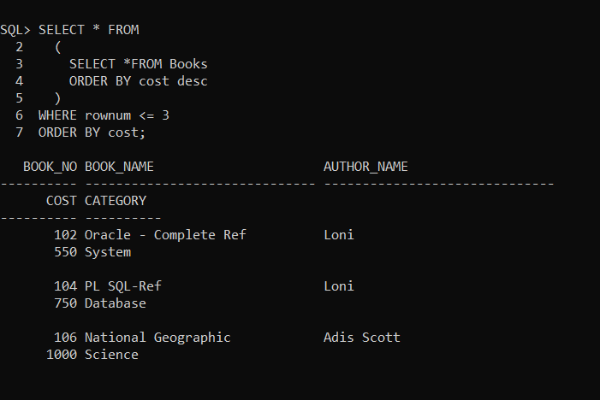

- List the total cost of all the books that are currently issued but not returned.

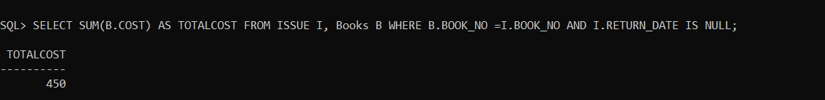

- List the details of the book that has been issued maximum no of times.

- List how many books are issued to lifetime members.

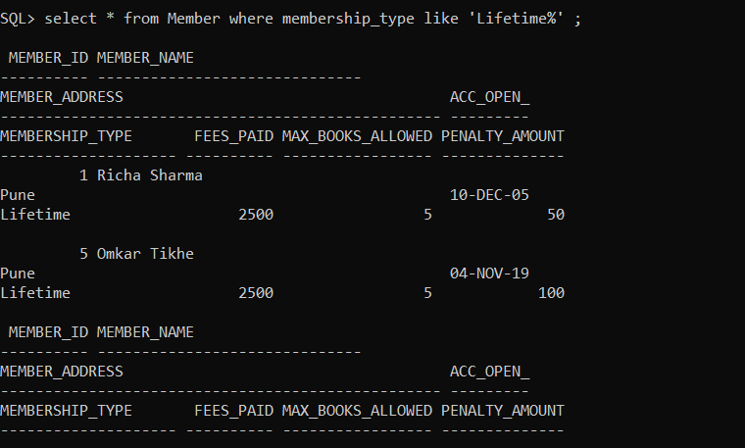

- List all member types and how many members are there in each type.

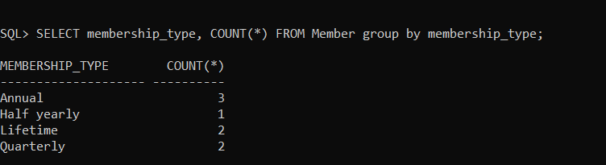

- Find out top 5 members, with their membership type, who have issued books maximum number of times.

- List top 3 members from each member type who have issued books maximum number of times.

- List first 5 members who had joined library.

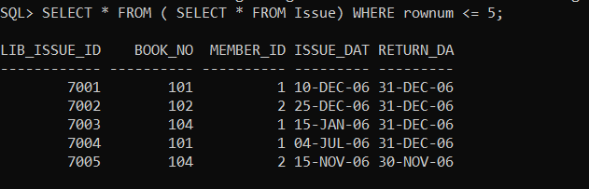

- List the members with their member type, who have issued books during the period 1st December to 31st December.

- List all the members who have not returned books yet.

- List all the members who joined library on the same date Garima joined.

- List all the members who has issued books from author “Loni” in the month of December

- List names of the authors whose books are least issued by lifetime members.

- List top 3 authors whose books are issued by half yearly members

- List top 5 books which are issued by Annual members

- List the names of members who has issued the books whose cost is more than 300 rupees and whose author is “Scott Urman”

39) Write a query to display number of booked in each category of books issued by all member types
Display output as follows
Member Type Book Category Count
--------------- ------------------ --------
Annual Science 10
Annual Fiction 5
Half yearly Science 4
. . .
. . .

- List all lifetime members who joined library during 1st January 2006 to 31st December 2006 but issued only one book.

